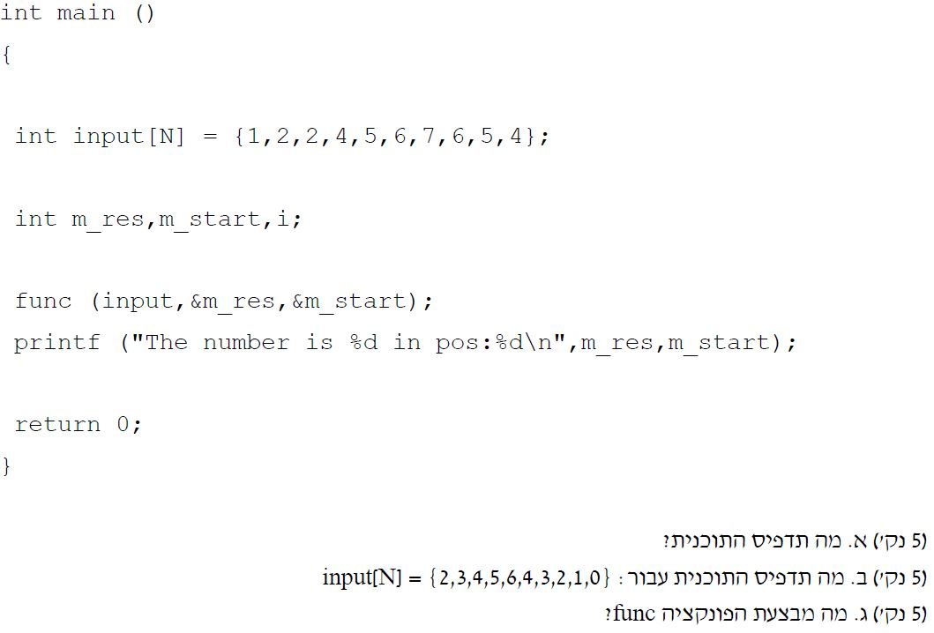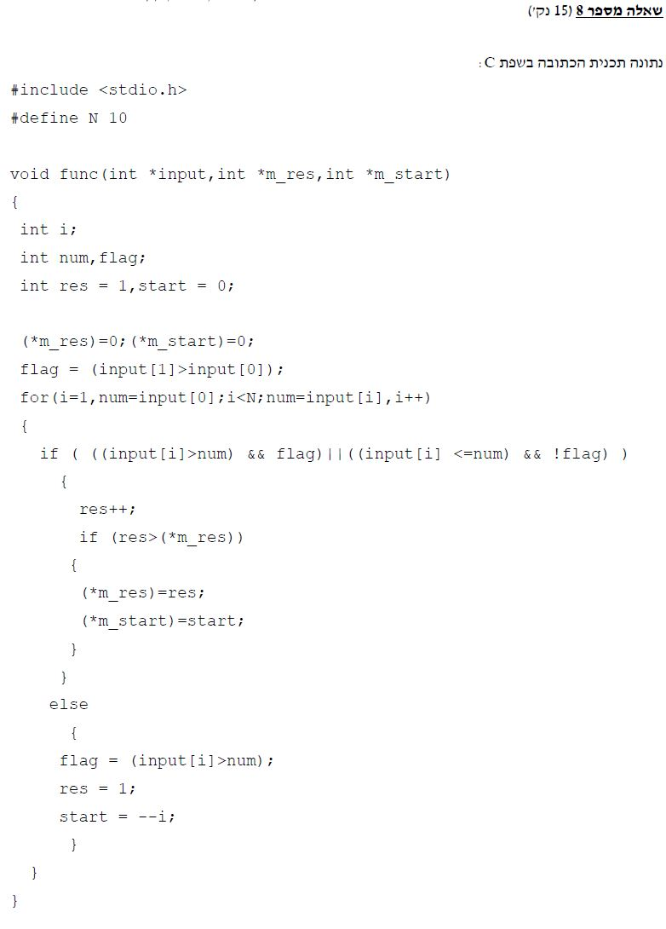

#include <stdio.h>

// This program will print the location and number of start,

// Of the largest sequence of numbers that ascend/descend.

// For the first array: 5, 2

// For the sec array: 6, 4

#define N 10

void func(int *input, int *m_res, int *m_start)

{

int i;

int num, flag;

int res = 1, start = 0;

(*m_res) = 0; (*m_start) = 0;

flag = (input[1] > input[0]);

for (i = 1, num = input[0]; i < N; num = input[i], i++)

{

if (((input[i] > num) && flag) || ((input[i] <= num) && !flag))

{

res++;

if (res > (*m_res))

{

(*m_res) = res;

(*m_start) = start;

}

}

else

{

flag = (input[i] > num);

res = 1;

start = --i;

}

}

}

int main()

{

int input[N] = { 1,2,2,4,5,6,7,6,5,4 };

// int input[N] = { 2,3,4,5,6,4,3,2,1,0 };

int m_res, m_start;

func(input, &m_res, &m_start);

printf("The number is %d in pos:%d\n", m_res, m_start);

getchar();

return 0;

}